**An Intelligent Chatbot for College Enquiry with Amazon Lex**

20IT113 20IT107 20IT096

**SHIV PATEL PRINCE PATEL JAINAM PATEL**

*Department of Information Technology Department of Information Technology Department of Information Technology*

*C S Patel Institute of Technology, CHARUSAT C S Patel Institute of Technology, CHARUSAT C S Patel Institute of Technology, CHARUSAT*

Changa, India Changa, India Changa, India

[20it113@charusat.edu.in](mailto:20it113@charusat.edu.in) [20it107@charusat.edu.in](mailto:20it107@charusat.edu.in) [20it096@charusat.edu.in](mailto:20it096@charusat.edu.in)

**Acknowledgments:** Many thanks to the Collage C S Patel Institute of Technology, CHARUSAT for giving me the opportunity to write a Research Paper on My Project. Thanks also to **Mr. JALPESH VASA** for leading us through all the sections of this research paper. Without his support it would have been very diffi- cult for me to prepare a meaningful and interesting paper.With this research paper I learned a lot about the on-premises services provided by the AWS (Ama- zon Web Service)and along with it we have used specific service to build this project fully based on Cloud Computing.

**Abstract:** People are looking for new ways to use technology to make their lives easier due to the increasing number of mobile and web applications. Chatting is an important part of everyday life with many applications and software. One of the most exciting and promising developments in human-machine interaction is the chatbot. We are going to implement an artificial intelligence based virtual assistant that can answer college-related queries... This includes interviews, admission inquiry questionnaires, fee structure, scholarship information etc. can answer various questions such as This paper focuses on establishing universities. Ask Chatbot to help stakeholders answer various questions using Amazon Lex. The conversation is built on Amazon Web Services (AWS) using Lambda Functions to configure the bot with words and responses in the form of a service called Amazon Lex, and to validate responses by performing actions using the Facebook Messenger service. The Lambda function runs a script that collects data in plaintext is sent to Amazon Lex by using various services provided by aws The chatbot then sends the appropriate response to the user connected to the device or in plain text

**Key Words: chatbot, Machine Learning, Amazon Web Services, Amazon Lex, Artificial Intelligence**

1. **INTRODUCTION**

The ability of chatbots to solve problems, save time and money increases the demand for them. Conversation has changed the way we communicate in recent years. Natural language processing, machine learning, robotics and electronic services, also known as chatbots, are considered the most popular applications of artificial intelligence to date. Therefore, chatbots are the most accessible systems for human users and are always available. Access to the Internet and other mobile devices or laptop devices can be used by anyone, anywhere, at any time, to answer questions without problems. College Chatbot Uses Machine Learning Concepts to Talk With People Usually, chatbots provide a text-based user interface that allows users to enter commands and receive text responses to solve problems.

1. **LITERATURE SURVEY**

Many applications can be implemented with the help of artificial intelligence. A variety of businesses can use chatbots, including marketing, education, banking, healthcare, and finance. Chatbot systems should also incorporate Natural Language Processing (NLP) and Machine Learning (ML) technologies for this.

Using AI / ML, P. Nihila, G. Jyoti, K. Mounika, Mr. C. Kishore KumarReddy and Dr. B.W. Various questions have been answered by Ramana Murthy [5]. (Artificial Intelligence Markup Language). Alicebot is a chatbot application created or developed using AIML, supported by ALICE free code.

NLP (Natural Language Processing) based synthetic conversation was proposed by Nitesh Thakur, Akshay Hivrale, Sourabh Selote, Abhijeet Shinde and Professor Namrata Mahakalkar [6]. NLP can be done in two ways: written text and vocal or audio dialogue. Written communication is simpler than oral communication. In the virtual human interaction system, this research explores some new possibilities to interpret and process information at an ever-increasing speed [6].

Uriurio Windiatmoo, Ridho Rahmadi, and Ahmad Fathan Hidayatullah [8] developed a deep learning chat that can be connected to Facebook Messenger.

## AMAZON WEB SERVICES

## AWS is a subsidiary of Amazon that provides management, cloud computing and data analytics services, etc. AWS offers built-in infrastructure. Business applications, robotics, content distribution, consumer interaction, end-user computing, storage, machine learning, development tools, databases, gaming technology and media services are among its offerings. Amazon's Lex AWS service allows developers to embed dialog interfaces and text-based dialogs into any application. With Amazon Lex's advanced deep learning capabilities, customers can create applications with stunning user interfaces and authentic conversational interactions. These capabilities include automatic speech recognition and natural language understanding to determine text intent. Anyone with programming skills can immediately set up a conversation with Amazon Lex. Amazon Lex can easily connect to multiple AWS technology platforms, including Amazon Cognito, AWS Mobile Hub, Amazon CloudWatch, and Amazon DynamoDB, and includes a pre-built interface with AWS Lambda. Saaforce, HubSpot, etc. Integration with Lambda allows bots to access enterprise connectors without pre-built servers to connect data on SaaS platforms such as

## 1. Simplicity: Amazon Lex builds a complete natural language model from the few sample sentences we provide, allowing bots to communicate using speech and text, ask questions, receive answers, and perform complex actions.

## 2. Deep Learning Technologies: The Conversational Language Understanding (SLU) system is built using ASR and NLU technologies from Amazon Lex, which uses technology like Alexa. Through SLU, Amazon Lex accepts natural language speech and text input, determines user intent, and satisfies by calling appropriate business functions.

## 3. Seamless deployment and scale - Amazon Lex allows you to easily deploy voice or text chat for use on mobile devices, web apps, and chat services Integrated integration with the AWS platform: Amazon Lex natively integrates with other AWS services such as Amazon. Cognito is compatible. , AWS Lambda, Amazon CloudWatch, and AWS Mobile Hub.

## There are no minimum payments or upfront fees with Amazon Lex. Only outgoing texts or requests are charged. The service is a low-cost solution for creating interactive interfaces due to its premium price and minimal cost per request.

## 

Fig 1. Amazon lex

## PROJECT WORKFLOW

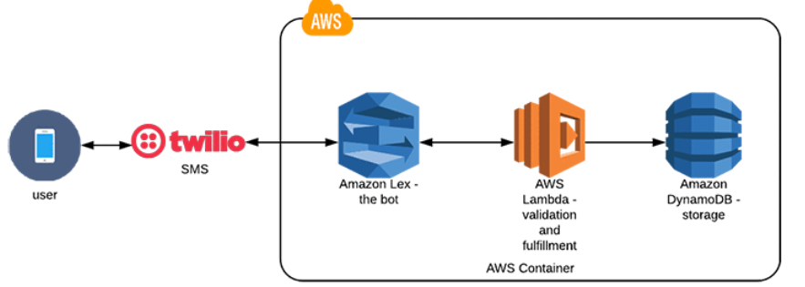

Fig 2. Project diagram

1. **Building the bot**

We start by building the bot. Open the AWS Management Console and create the bot in the Amazon Lex console.

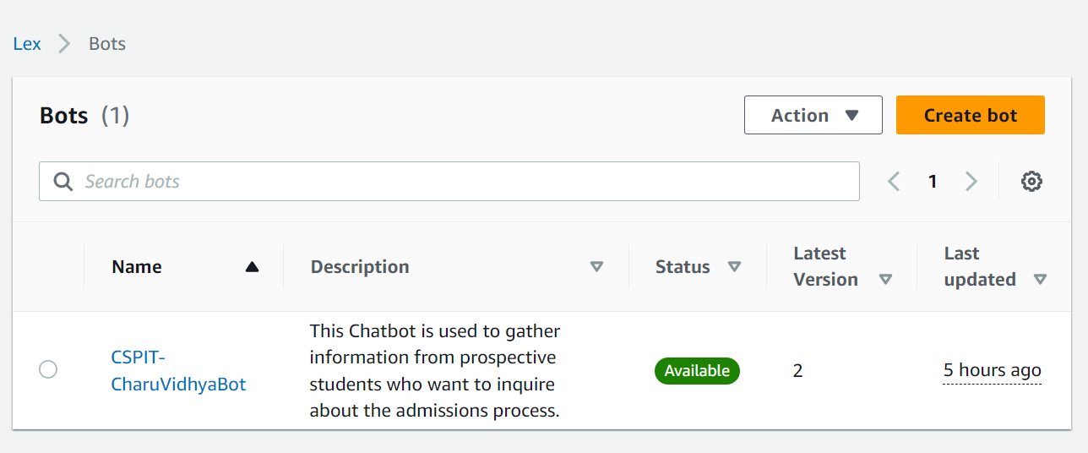

Fig 3. Bot details

1. **Configuration of the bot**

Configured bot by creating intents and its related slots with appropriate slot types along with some initial responses and additional configuration where ever requires

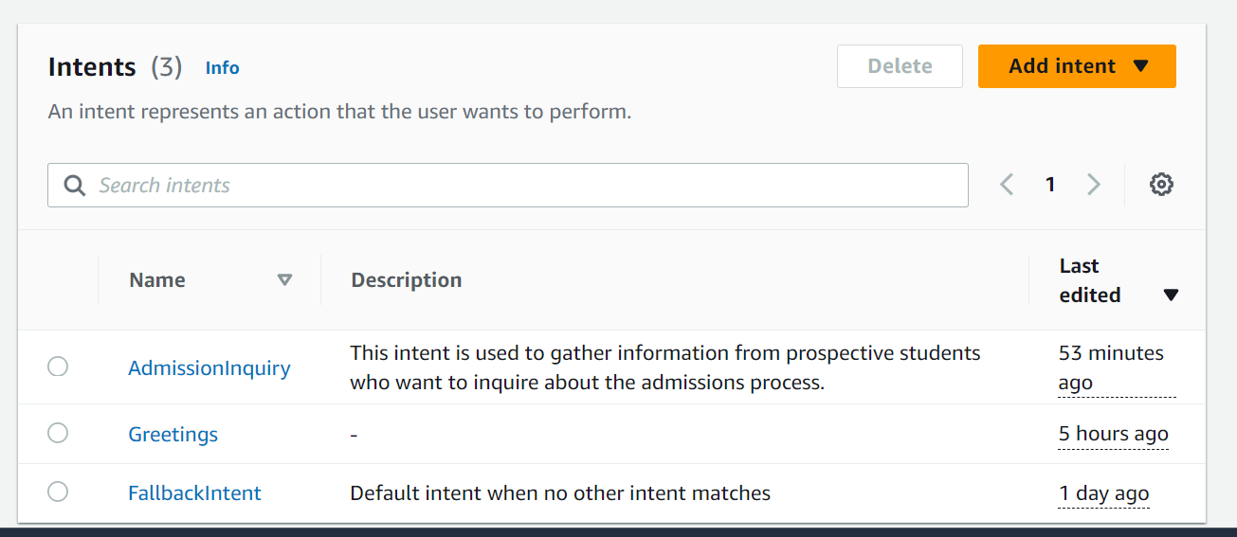

Fig 4. Intents

1. **Connection with lambda function**

Amazon Lex chatbots can connect to AWS Lambda functions to provide dynamic response and backup functionality. Here's how to link your Amazon Lex chatbot to your Lambda function

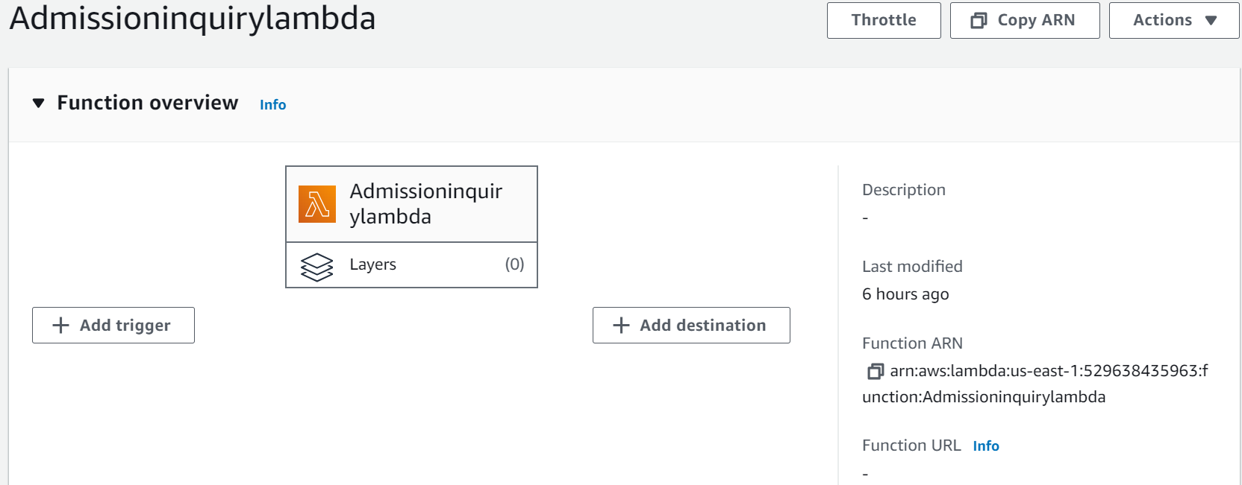

Fig 5. Connect with lambda function

1. **Tesing in amazon lex console**

* Select the specific chatbot you want to test.
* Find the "Test Chatbot" section in the chatbot settings.
* Interact with your chatbot using the built-in chat simulator in the Amazon Lex console. Chatbot.
* Access the model using the login and evaluate the response generated by the chatbot. This allows you to test and optimize chatbot interactions.

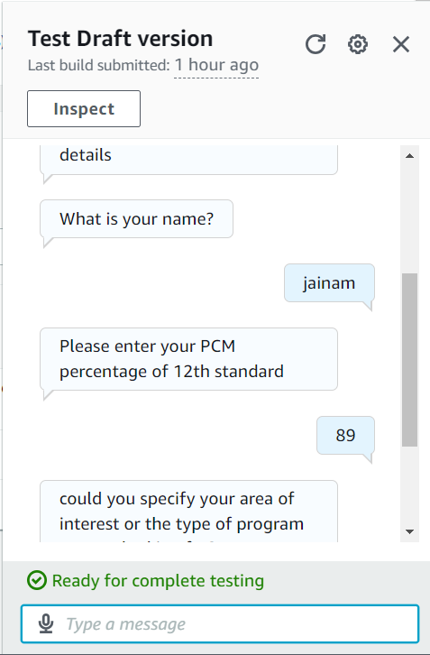

Fig 6. Test the intent and got output

1. **Tesing by whatsapp using Twilio**

**What is Twilio?**

Twilio is a cloud-based communications platform that provides a wide range of APIs and services for building real-time communications applications. It offers solutions for SMS, voice, video and other forms of communication. Twilio is useful for testing chatbots on WhatsApp and other messaging platforms because it allows you to send and receive messages programmatically. Here's how Twilio can be useful for testing chatbots on WhatsApp:

1. **Whatspp integration:** Twilio provides a WhatsApp Business API that enables businesses to send and receive messages on WhatsApp. By integrating your chatbot with Twilio's WhatsApp API, you can interact with users on WhatsApp, one of the most popular messaging platforms.
2. **Automated Testing:** You can use Twilio to send automated messages to your chatbot on WhatsApp, simulating user interactions. This allows you to test how your chatbot responds to different types of messages and ensures that it functions correctly on the WhatsApp platform.
3. **Real User Testing:** Twilio's WhatsApp API enables you to engage with real users on WhatsApp for testing purposes. You can invite testers or use your own WhatsApp number to interact with the chatbot and collect feedback. This is particularly valuable for user acceptance testing and real-world scenario testing.
4. **Message Logging and Analysis:** Twilio provides message logging and analytics, allowing you to review the message history and analyze how your chatbot performs over time. You can track the messages sent and received, as well as any errors that may occur during interactions.
5. **Scalability:** Twilio is a scalable and reliable platform, making it suitable for handling large-scale testing and production deployments. It can handle high volumes of messages, ensuring that your chatbot performs well under load.

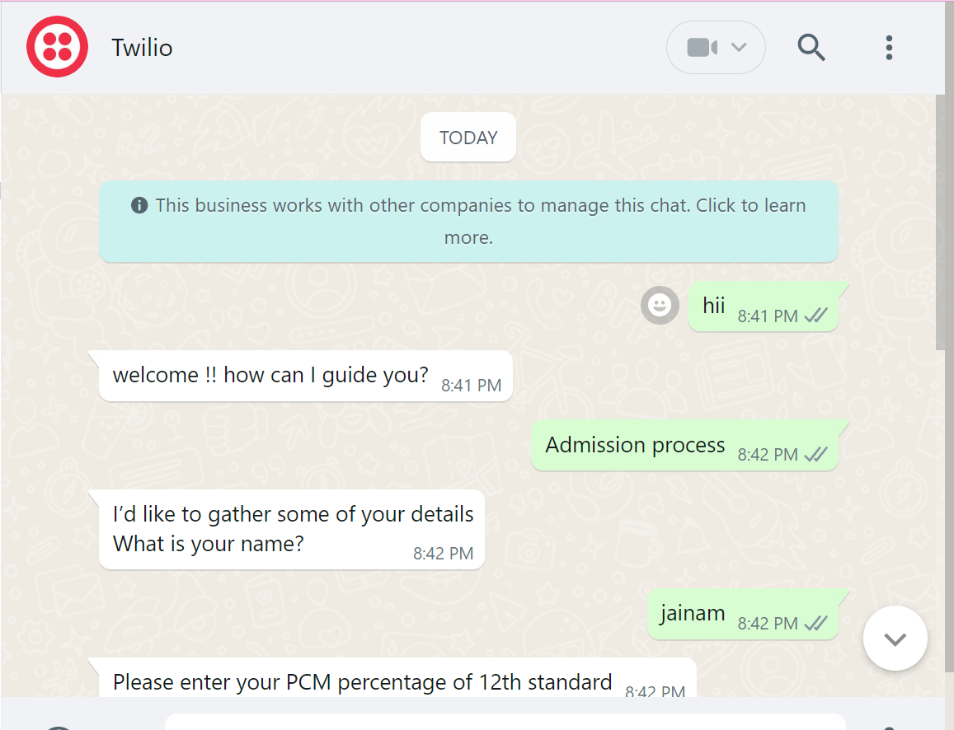

Fig 7. Test using twilio whatsapp integration

## CONCLUSION

## The proposed system reduces the paperwork, labor and time required by each individual. In this paper, we have created a hatBOT that can interact with various users by reducing the time of visiting the college to inquire about admission details / information, college work, etc. Common answers are created for questions unrelated to the intentions expressed in the interview, and such questions must be checked and entered into the database.

## REFERENCE

## 1. Bhaumik Kohli, Tanupriya Chowdhury, Shilpi Sharma, Pravin Kumar., "A Platform for Human Conversation Using Python", IEEE, 2018

## 2. Chung, Minji, Ko, Eunju, Jeong, Heerim and Kim, Sang Jin. (2020) "e-Chatbot service and customer satisfaction for luxury brands." Journal of Business Research 117: 587-595.

## 3. Adamopoulou, Eleni and Mousiades, Lefteris. (2020) "Communication: History, Technology, and Applications." Machine learning and programming

## 4. Jitendra Purohi, Aditya Bagwe, Rishbh Mehta, OjaswiniMangaonkar, Elizabeth George, "Deep-Conversational Chatbot Based Natural Language Processing", IEEE, 2019.

## 5. P. Nihila, G. Jyoti, K. Mounika, Mr. C Kishore Kumar Reddy and Dr. B V Ramana Murthy, "Interview Using Artificial Intelligence", International Journal of Research and Development, Volume VIII, Issue I, January / 2019, ISSN NO: 2236-6124, page 1-12.

## 6. Nitesh Thakur, Akshay Hiwrale, Sourabh Selote, Abhijeet Shinde and Prof. -47.

## 7. Amazon Lex, 2021 [Online]. Available at: https://aws.amazon.com/lex/ AmazonS3/latest/user-gui/add-bedre-policy.html

## 8. Windiatmoko, Y.., Rahmadi, R. and Hidayatullah, A.F., 2021, February. "Deep Learning Based Facebook Chatbot Development Using RASA Framework for University Research". In IOP Conference Series: Materials Science and Engineering (Vol. 1077, No. 1, pp. 012060). Publication of IOP.

## 9. Payal Jain, "College Research ChatBot Using Iterative Modeling", International Journal of Science Engineering and Research (IJSER), ISSN (Online): 2347-3878, Volume 7, January 1, 2019, 80 - page 83.